**How to configure VLAN and interVLAN Routing in Packet Tracer**

Welcome to this tutorial! This is a simple step by step guide of configuring **VLAN** and **interVLAN routing** on a Cisco switch. But just before get into configurations , let’s have a brief overview of what’s  a VLAN.

**What is a VLAN?**

A Virtual LAN (**VLAN)** is simply a logical LAN, just as its name suggests. VLANs have similar characteristics with those of  physical LANs, only  that  with VLANs, you can logically group  hosts even if they are physically  located on separate LAN segments.

We treat each VLAN as a separate subnet or broadcast domain. For this reason, to move packets from one VLAN to another, we have to use a router or  a layer 3 switch.

VLANs are configured on switches by placing some interfaces into one broadcast domain and some interfaces into another. For this tutorial, we’ll configure 2  VLANs  on a switch. We’ll  then proceed and configure a router to enable communication between the two VLANs.

So then,

1. In Cisco Packet Tracer, **create the network topology** as shown below:

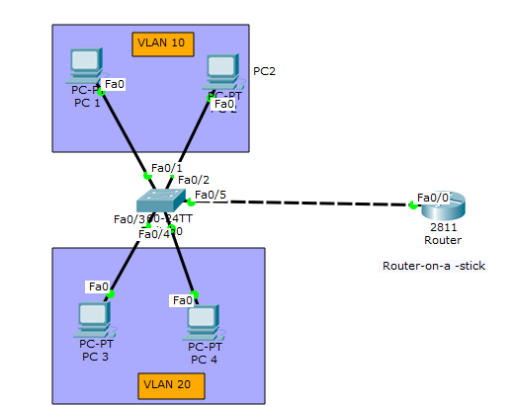

Advertisement

**2. Create 2 VLANs on the switch:** VLAN 10 and VLAN 20. You can give them custom names.

Switch#config terminal

Switch(config)#vlan 10

Switch(config-vlan)#name SALES

Switch(config-vlan)#vlan 20

Switch(config-vlan)#name IT

**3.** **Assign switch ports  to the VLANs.** Remember each VLAN is viewed as separate broadcast domain.

And just before you configure, have in mind that switch ports could be either access or trunk.

* An *access port* is  assigned to a single VLAN . These ports are configured for switch ports that connect to devices with a normal network card, for example a PC in a network.
* A *trunk port* on the other hand is a port that can be connected to another switch or router. This port can carry traffic of multiple VLANs.

So in our case, we’ll configure switch interfaces fa 0/1 through fa 0/4 as access ports to connect to our PCs. Here, interfaces fa 0/1 and fa 0/2 are assigned to **VLAN 10** while interfaces fa 0/3 and fa 0/4 are assigned to **VLAN 20.**

Switch *Interface* fa0/5 will be configured as  trunk port, as it will be used to carry traffic between the two VLANs via the router.

Switch>enable

Switch#config terminal

Switch(config)#int fa0/1

Switch(config-if)#switchport mode access

Switch(config-if)#switchport access vlan 10

Switch(config-if)#int fa0/2

Switch(config-if)#switchport mode access

Switch(config-if)#switchport access vlan 10

Switch(config-if)#int fa0/3

Switch(config-if)#switchport mode access

Switch(config-if)#switchport access vlan 20

Switch(config-if)#int fa0/4

Switch(config-if)#switchport mode access

Switch(config-if)#switchport access vlan 20

*Worth noting*: We could have configured all the above interfaces as access ports using *interface range* command as shown below:

Switch(config-if)#int range fa0/1-4

Switch(config-if-range)#switchport mode access

In the above commands, we have specified an interface range and then proceeded to configure all the ports specified as access ports.

Advertisements

Report this ad

Interface fa0/5 is configured as *trunk* and will be used to  for inter-VLAN communication.

Switch(config)#int fa 0/5

Switch(config-if)#switchport mode trunk

The next thing is to:

**4 .** Assign static IP addresses to the four PCs which are located in the separate VLANs. PC1  and PC2  fall in VLAN 10  while PC3 and PC4 fall in VLAN 20.

**PC1**   **IP address** 192.168.1.10   **Subnet mask** 255.255.255.0  **Default gateway** 192.168.1.1

**PC2:** **IP address** 192.168.1.20  **Subnet mask** 255.255.255.0  **Default gateway** 192.168.1.1

**PC3: IP address** 192.168.2.10    **Subnet mask** 255.255.255.0  **Default gateway** 192.168.2.1

**PC4: IP address**  192.168.2.20 **Subnet mask**   255.255.255.0  **Default gateway** 192.168.2.1

And now it’s very clear that we treat a VLAN just like a physical LAN when assigning IP addresses.

At this point let’s try to test connectivity **within** VLANs and **between** VLANs

To test communication between hosts in the same VLAN:

Ping PC2 from PC1 both in VLAN 10. Ping test should be successful.

To test connectivity between hosts in different VLANs:

Ping PC3 in VLAN 20 from PC1 in VLAN 10. Ping  here will definitely fail. Why? Because **inter-VLAN routing** is not yet enabled. Hope you can see how  we’ve used VLANs to place the hosts into two  logical networks which can be viewed as separate broadcast domains.

Advertisements

Report this ad

Now, in order to allow the hosts in the two VLANs to communicate, we need to do something extra. And you can guess what. We’ll configure the router to permit  inter-VLAN communication. Let’s do that right away.

**5. Configure inter-VLAN routing on the router**

We’ll configure the router so that it will enable communication between the two vlans via a single physical interface. How is this made possible? We’ll divide the single physical interface on the router into logical interfaces (sub interfaces). Each sub-interface will then serve as a default gateway for each of the VLANs. This scenario is called **router on a stick** (R.O.A.S) and will allow  the VLANs to communicate through the single physical interface.

*Wort noting*:  We**can’t** assign an IP address to the router’s physical interface that we have subdivided into  logical sub-interfaces. We’ll instead assign IP addresses to the sub interfaces.

So let’s do router configurations:

Router>enable

Router#config terminal

Router(config)#int fa0/0

Router(config-if)#no shutdown

Router(config-if)#int fa0/0.10

Router(config-subif)#encapsulation dot1q 10

Router(config-subif)#ip add 192.168.1.1 255.255.255.0

Router(config-subif)#

Router(config-subif)#int fa0/0.20

Router(config-subif)#encapsulation dot1q 20

Router(config-subif)#ip add 192.168.2.1 255.255.255.0

As you can notice from above, the routers physical interface fa0/0  was subdivided into two sub-interfaces( fa0/0.10 and  fa0/0.20) *,* which are then configured as *trunk* interfaces and given IP addresses.

Advertisements

Report this ad

Finally,

**6.** Test **inter-VLAN** connectivity.

Here we’ll test connectivity between computers in different VLANs . Don’t forget that its the router that enables  inter-VLAN routing.

Ping PC3 in **VLAN  20** from PC1 in **VLAN 10**. If everything is well configured, then ping should work perfectly.